Press release Sulz am Neckar, Germany, August 2017

Maximum compatibility

UNI lock clamping technology saves setup times

HEINRICH KIPP WERK offers several clamping systems that are all compatible with each other. An example is the UNI lock 5-axis mudule system combined with the UNI lock zero-point clamping system.

The KIPP catalogue Clamping technology contains a multitude of modular systems and components. They are all compatible with each other and freely combinable.
Two of these systems with the name "UNI lock" compliment each other perfectly. The combination of "Zero-point clamping system" and „5-axis module system" enable highly efficient machine utilisation.

When the machine table is set up with the zero-point clamping system, other KIPP clamping systems such as the 5-axis module system or the 5-axis vices can be exchanged within seconds.

The mounted 5-axis module system is excellent for 5 side machining of complex, small to medium workpieces. The parts can be clamped with the 5-axis module system or directly on the zero-point clamping system. Unproductive auxiliary processing times such as renewed clamping or positioning are completely eliminated.

The repeatability of both systems is within 0.005 mm. The central element is the clamping pin that is universal for all clamping systems. Due to the wide selection of pins, almost any workpiece can be clamped. The clamping pins interlock positively with the clamping element.

The 5-axis module system from KIPP is not only available in the system size 80, but can be expanded with the system size 50. Both can be combined with each other leading to further diverse possibilities of workpiece clamping.
System size 50 advantages: 5-side machining without protruding edges of small components. The clamping force is up to 10 kN.
Characters including spaces:
Headline: 46 characters
Pre-head: 21 characters
Text: 1.678 characters
Total: 1.745 characters

HEINRICH KIPP WERK KG
Stefanie Beck, Marketing
Heubergstrasse 2
72172 Sulz am Neckar, Germany

Telephone: +49(0)7454 793-30
Email: stefanie.beck@kipp.com

Additional information and press photos
See www.kipp.com, Region: Germany, Category: News / Press area

Photo

Compatibility of KIPP UNI lock system sizes 50/80  Photo: KIPP  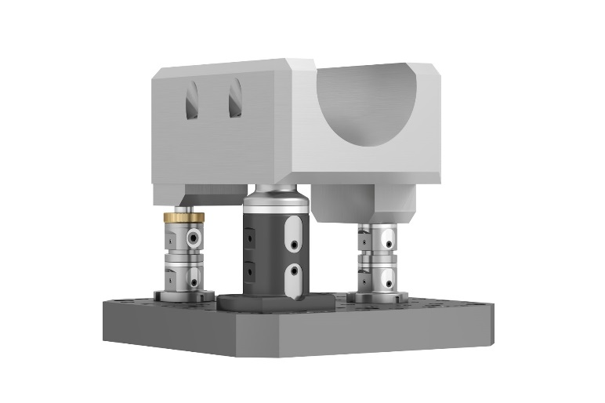 | Image file:  KIPP-Werkstückspannung-UNI lock-01.jpg

KIPP 5-axis module system UNI lock system sizes 50/80.  Photo: KIPP  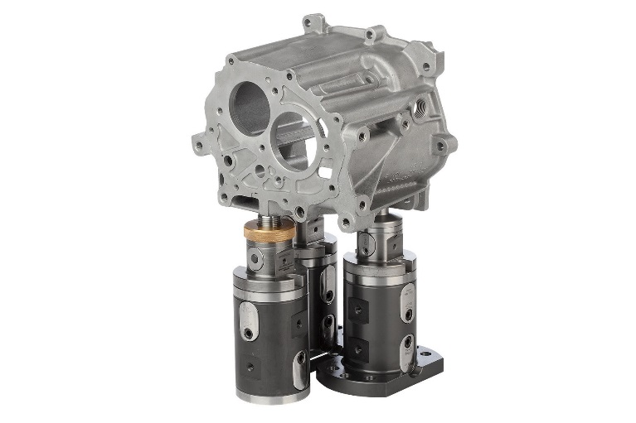 | Image file:  KIPP-Werkstückspannung-UNI lock-02.jpg

Image copyright: Released for licence-free and royalty-free publication in speciality media.
Please cite the source and submit a reference.

