Press release Sulz am Neckar, Germany, April 2015

100% design

Carbon fibre TUBULAR HANDLES: High-quality Handles for Premium Class

HEINRICH KIPP WERK is showcasing an exclusive product upgrade at the 2015 HANNOVER TRADE FAIR: the carbon fibre TUBULAR HANDLE. The high-quality handle features an impressive, innovative design and extreme stability. It is used in the premium sector for interior fittings and furnishings.

KIPP is using the 2015 HANNOVER TRADE FAIR to launch the sale of a new, exclusive product. The company's product range of handles has been extended to include the carbon fibre TUBULAR HANDLE. The primary features of this handle are extreme stability, high-quality design, highly resistant materials and long service life.

The combination of stainless steel and real carbon fibre materials gives the handle a visually striking look. The carbon fibre surface is grinded several times to strengthen the material's depth effect. A clear coat and hand polish underline the first-class quality of this product. Thanks to its ergonomic shape, special design and high-quality visual look, the carbon fibre TUBULAR HANDLE is ideal for use in interior design and fittings or other high-end areas.

Carbon fibre handles have up until now only been available as custom made products. HEINRICH KIPP WERK now offers these handles as standard products directly ex works. Two models of the carbon fibre TUBULAR HANDLE are available each in six different sizes and in special lengths on request.

Characters including spaces:
Headline: 69 characters
Pre-head: 12 characters
Text: 1.366 characters
Total: 1.447 characters

HEINRICH KIPP WERK KG
Stefanie Beck, Marketing
Heubergstrasse 2
72172 Sulz am Neckar, Germany

Telephone: +49(0)7454 793-30
e-mail: s.beck@kipp.com

Additional information and press photos
See www.kipp.com, Region: Germany, Category: News/Newsroom

Photos

Image text:
The carbon fibre TUBULAR HANDLE features an impressive, outstanding design and extreme stability.
Photo: KIPP

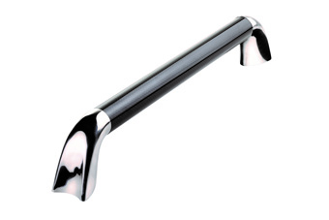  Image copyright: Released for licence and royalty-free publication in speciality media.  With the request to cite the source and receipt. | Image file:  KIPP_ROHRGRIFF_carbon_K0781.jpg

